Problem​ ​Statement​ ​1:

You survey households in your area to find the average rent they are paying. Find the

standard deviation from the following data:

$1550,​ ​$1700,​ ​$900,​ ​$850,​ ​$1000,​ ​$950.

Problem Solution:

Formulae:

1. Mean for a sample

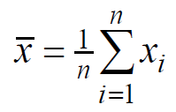

1. Standard Deviation for a sample

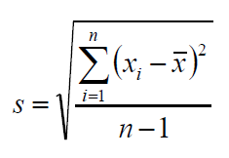

Solution:

Rearranging the given sample in ascending order

850,900,950,1000,1550,1700

Xbar = (850+900+950+1000+1550+1700)/(6-1)

Xbar = 1390 => Mean

S = sqrt(((850-1390)^2+(900-1390)^2+(950-1390)^2+(1000-1390)^2+(1550-1390)^2+(1700-1390)^2)/(6-1))

S = sqrt((291600 + 240100 + 193600 + 152100 + 25600 + 96100)/5)

S = sqrt(199820)

S = 447.0123 => Standard Deviation